# 人教版2019-2020年初二英语上册Units1-2单元测试卷(含答案)

# Units 1～2综合检测卷

时间：120分钟　　满分：120分

|  |  |  |  |  |  |  |  |  |  |  |  |
| --- | --- | --- | --- | --- | --- | --- | --- | --- | --- | --- | --- |
| 题序 | Ⅰ | Ⅱ | Ⅲ | Ⅳ | Ⅴ | Ⅵ | Ⅶ | Ⅷ | Ⅸ | Ⅹ | 总分 |
| 得分 |  |  |  |  |  |  |  |  |  |  |  |

听力部分(共25分)

Ⅰ.听句子，选择正确的答语。听两遍。(5分)

(　 )1.A.It was wonderful. 　　　B．I went to the beach.

C．By train.

(　 )2.A.Yes，they did. 　　　B．On Monday.

C．His father.

(　 )3.A.It's an umbrella. 　　　B．I was very hungry.

C．It was very delicious.

(　 )4.A.She went shopping. 　　　B．She was bored.

C．It was beautiful.

(　 )5.A.Take photos. 　　　B．Last month.

C．Very tired.

Ⅱ.听对话，选择正确的答案。听两遍。(5分)

(　 )6.Where did the girl go during her vacation?

A.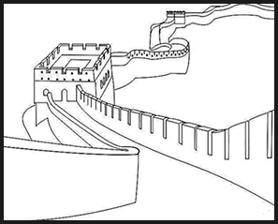 B.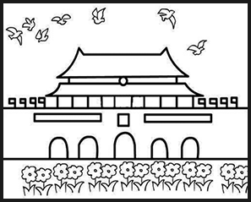 C.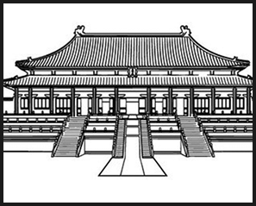

(　 )7.What kind of junk food does Peter love to eat?

A.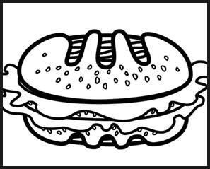 B.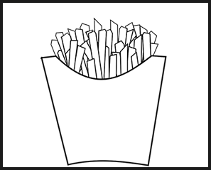 C.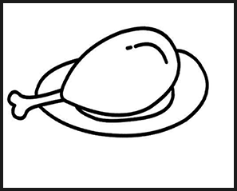

(　 )8.What does Ann often do on weekends?

A.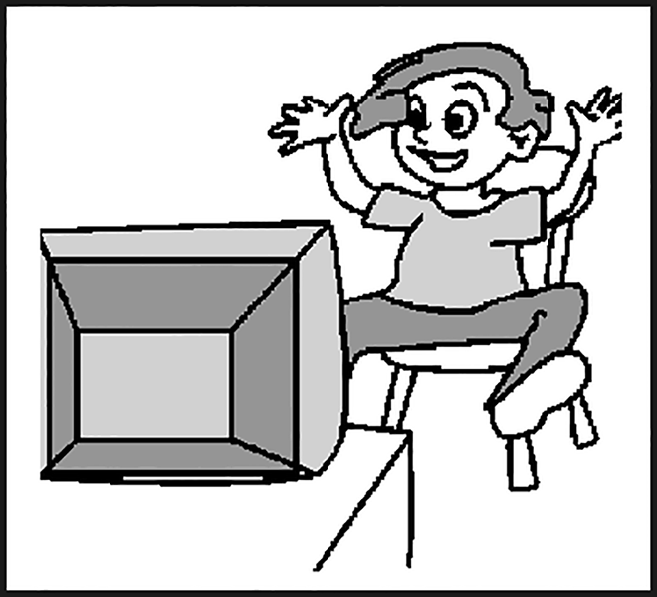 B.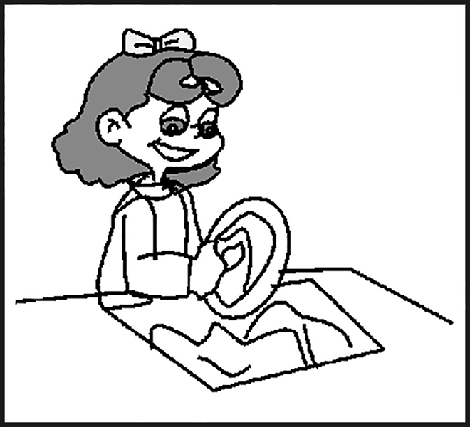 C.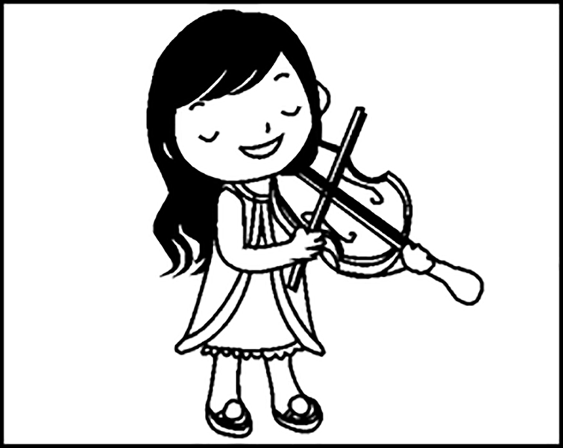

(　 )9.How was the weather yesterday?

A.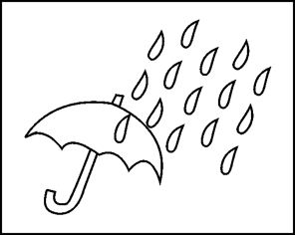 B.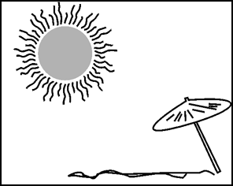 C.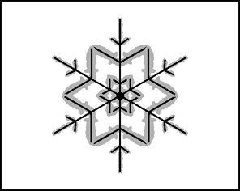

(　 )10.What did Alice buy for himself in Beijing?

A.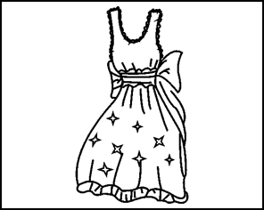 B.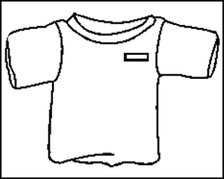 C.

Ⅲ.听两段对话，选择正确的答案。听两遍。(5分)

听下面一段对话，回答第11至12小题。

(　 )11.How long did Susan stay in Australia?

A．For half a month. 　　　B．For a month.

C．For two months.

(　 )12.What did Susan buy for Mark?

A．A pen. B．A book. C．A T－shirt.

听下面一段对话，回答第13至15小题。

(　 )13.Does the girl often exercise?

A．No，she doesn't. 　　　B．Yes，she does.

C．We don't know.

(　 )14.How often does the girl exercise?

A．Sometimes. 　　　B．Every day.

C．Twice a week.

(　 )15.Where does the girl usually go for vacation?

A．She usually goes to the beach.

B．She usually goes to the mountains.

C．She usually goes to Beijing.

Ⅳ.听短文，选择正确的答案。听两遍。(10分)

(　 )16.Where does Cindy come from?

A．China. B．The US. C．The UK.

(　 )17.What time does Cindy get up every morning?

A．At 6：00. B．At 6：30. C．At 7：30.

(　 )18.How often does Cindy play tennis with her friends?

A．Once a week. 　　　B．Twice a week.

C．Once a month.

(　 )19.What's Cindy's favorite junk food?

A．Ice－cream. B．Cake. C．Hamburger.

(　 )20.How long does Cindy usually sleep every night?

A．For eight hours. 　　　B．For nine hours.

C．For ten hours.

笔试部分(共95分)

Ⅴ.单项选择。(15分)

(　 )21.—I ______ what the TV play *Agni* *Cantabile*《烈火如歌》 is about.Can you tell me?

—OK.

A．enjoy B．decide C．try D．wonder

(　 )22.—I can't find my CDs.

—______ you put them in that bag.

A．Only B．However C．Maybe D．Still

(　 )23.—Did you go shopping in Hong Kong?

—______.I bought many nice things there.

A．No，I didn't B．I am afraid not

C．Of course D．Not really

(　 )24.—______ do you use the Internet?

—Twice a week.

A．How many B．How long

C．How much D．How often

(　 )25.______ it was very cold this morning，______ my friends still went swimming.

A．Although；but B．Although；/

C．But；although D．/；although

(　 )26.The cartoon *Peter* *Rabbit*《彼得兔》 seems ______ popular.Many children like it.

A．be B．to be C．being D．is

(　 )27.Hawking(霍金)______ on March 14th，2018.

A．born B．died C．decided D．tried

(　 )28.—I don't like the movie *Detective* *Chinatown* Ⅱ《唐人街探案2》．

—I ______ it，either.

A．like B．dislike C．liked D．disliked

(　 )29.If I can't open the door，you'll have to climb ______ the window.

A．through B．across C．at D．below

(　 )30.I like doing exercise in my free time，______ playing basketball and running.

A．more than B．less than

C．at least D．such as

(　 )31.It's bad for your health to eat more food when you are ______.

A．hungry B．free C．full D．busy

(　 )32.—Can you tell me the ______ of the 2018 Winter Olympics in Pingchang?

—Of course I can.Norway got the first place.

A．result B．wonder C．program D．activity

(　 )33.My mother ______ every day，but she ______ yesterday.

A．exercises；doesn't B．exercises；didn't

C．exercised；doesn't D．exercised；didn't

(　 )34.—Today the weather is very cold and I ______ see people outside.

—Yes.They all stay at home and keep warm.

A．always B．hardly C．often D．only

(　 )35.—Did you have a good time in Disneyland in Shanghai last week?

—______，it was too hot.

A．Not really B．Yeah，why not

C．Oh，great D．You're right

Ⅵ.完形填空。(10分)

Yesterday I visited Shanghai Disneyland with my parents.You must __36__ how I felt.Well，it's hard to say.

At first I had a great __37__．I saw my favorite Mickey Mouse and many other Disney characters(角色)．And I watched some shows.They were __38__．I also bought __39__ special for my friends.However，the park was full __40__ people.For every ride，I had to __41__ for at least one hour，and sometimes two hours.In the afternoon，it started raining.We didn't take a(n) __42__．I wanted to wait for the rain to stop，but my parents __43__ to go back home.

I want to visit the Disneyland __44__ in summer.I'm sure it will be better then.And next time I will bring enough food and drinks __45__ the things in the park are too expensive.

(　 )36.A.worry B．know C．read D．wonder

(　 )37.A.festival B．time C．taste D．mind

(　 )38.A.boring B．difficult

C．terrible D．wonderful

(　 )39.A.nothing B．something

C．anything D．everything

(　 )40.A.by B．of C．with D．for

(　 )41.A.wait B．feel C．want D．hope

(　 )42.A.bicycle B．jacket C．computer D．umbrella

(　 )43.A.learned B．forgot C．decided D．seemed

(　 )44.A.again B．too C．often D．yet

(　 )45.A.although B．but C．because D．so

Ⅶ.阅读理解。(40分)

**A**

Tomiko has a good time in New York.She is studying English in Columbia University(大学)．She will(将要) finish her classes in June.Then she will work in New York.

Tomiko likes the beautiful buildings in New York.She wants to become an architect(建筑师)．Then she can build great buildings，too.

Tomiko also likes the people in New York.They come from different countries and speak different languages.Tomiko has many friends from other countries.

Best of all，Tomiko loves the museums in New York.She visits them almost every week.And she visited all the museums in the city.

New York is far from her home in Tokyo，but Tomiko is happy.She goes to classes every day.She visits her friends.She goes to see new places.And she watches many movies.She is very busy and happy in New York.

(　 )46.From the first paragraph(段落)，we can know that ______.

A．Tomiko is studying Chinese in a university

B．Tomiko is not happy to study in New York

C．Tomiko's English classes will finish in June

D．Tomiko will leave New York in June

(　 )47.The writer talks about the ______ of New York in the passage.

①museums　②history　③food　④people

A．②④ B．②③④ C．①③④ D．①④

(　 )48.Where does Tomiko come from?

A．Shanghai. B．Columbia.

C．New York. D．Tokyo.

(　 )49.How often does Tomiko visit the museums in New York?

A．Every day. B．Almost every week.

C．Every month. D．Never.

(　 )50.The passage is mainly about ______.

A．what Tomiko likes in New York

B．what Tomiko will do in the future(在将来)

C．how to live a happy life in New York

D．how to make friends in New York

**B**

It's enjoyable to do housework.The feeling is fantastic when you see your house become clean and tidy.How often do you do housework？The following is my housework frequency(频率)．

Cooking：twice a day(We all have lunch outside.I have to say food in restaurants usually tastes more delicious，but it's not healthy.I love cooking healthy food for my family.)

Cleaning the house：once a day(I usually tidy up after dinner.It's a good way to exercise.)

Washing clothes：once a day in summer；twice a week in winter(Sometimes my daughter helps me with it.She is helpful.)

Garden work：once a month(My husband(丈夫)and my son usually do the garden work.I just water the flowers.)

(　 )51.How does the writer feel about doing housework?

A．It's boring. B．It's hard.

C．It's enjoyable. D．It's important.

(　 )52.How often does the writer cook?

A．Once a day. B．Twice a day.

C．Three times a day. D．Twice a week.

(　 )53.When does the writer usually clean the house?

A．On weekends. B．In the morning.

C．In the afternoon. D．After dinner.

(　 )54.Who helps the writer wash clothes?

A．Her daughter. B．Her husband.

C．Her son. D．Her friend.

(　 )55.Which of the following is TRUE?

A．The writer has a house near her office(办公室)．

B．The writer often has breakfast outside(在外面)．

C．The writer does garden work once a week.

D．The writer has a daughter and a son.

**C**



Do you wonder where to go in the summer holidays？Well，let me tell you：Jamaica(牙买加)．When I was there，I had the greatest time of my life.The Jamaicans are very friendly.My friends and I couldn't stop listening to Jamaican music after we first heard it.

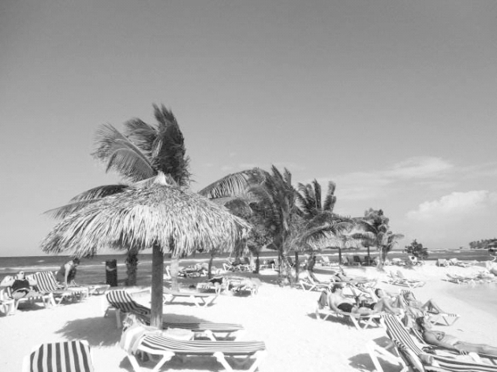

Everything about Jamaica is just beautiful.There are white beaches and the water is so clean.You can see everything from coral(珊瑚) to all kinds of fishes.Another great thing is all the delicious fruit.

My favorite food is the sugar cane(甘蔗) in Jamaica.One of the most interesting things was the Glistening Waters.We went swimming there in the dark.It was really wonderful.Another fun thing was climbing Dunn's River Falls，a huge waterfall(瀑布)．Another cool thing was the lizards．They climb up the walls of buildings.Go ahead and try to catch them.Believe me，you will find they are smart and fast.

There are so many great and interesting places to visit in Jamaica.Jamaica is one of the most wonderful places，and I think you should go there soon.One more thing—don't forget to drive on the left of the road.Haha…

(　 )56.What does the writer think of Jamaicans?

A．Friendly. B．Fun.

C．Happy. D．Boring.

(　 )57.What is the writer's favorite food in Jamaica?

A．The fish. B．The sugar cane.

C．The beef. D．The bananas.

(　 )58.What does the underlined word mean in Chinese?

A．蝌蚪 B．熊 C．娃娃鱼 D．蜥蜴

(　 )59. How should we drive if we go to visit Jamaica?

A．Drive on the right of the road.

B．Drive on the left of the road.

C．Drive in the middle of the road.

D．Drive any way as we wish.

(　 )60.Which of the following can we know?

A．The music in Jamaica is wonderful.

B．The beaches and the water are not clean.

C．Visitors can't swim in the Glistening Waters.

D．Visitors can see many scary animals in Jamaica.

**D**

It's OK to eat fast food occasionally(偶尔) but fast food is high in calories(热量).61.Don't__often__eat__a__hamburger__and__chips，or__you__can__easily__become__fat.You must eat homemade food because it is healthier.

Everybody knows that fast food is cheap and quick.However fast food is not as tasty as homemade food.Young people prefer(更喜欢) to eat pizzas，hamburgers and French fries，62.________ they should have soup instead.Fast food companies spend lots of money in order to make people believe that fast food is cool.63.美国人每周吃三个汉堡。

Fatness can lead to(导致) other diseases(疾病).64.This__is__why__America__is__now__starting__to__fight__back__against__the__fast__food__companies(公司)．They are stopping serving fast food in school dining hall and restaurants serving traditional(传统的) food are opening now.

任务一：61.将61处画线部分句子用if改写成同义句。

________________________________________________________________________

任务二：62.将62处填入一个词，使句意通顺。

________________________________________________________________________

任务三：63.将63处画线句子译成英语。

________________________________________________________________________

任务四：64.将64处画线句子译成汉语。

________________________________________________________________________

任务五：65.请给短文拟个标题。

________________________________________________________________________

Ⅷ.根据句意及所给汉语提示写单词。(5分)

66．It's ________(有乐趣的)to plant trees in the mountain.

67．You never know how interesting it is if you don't ________(尝试) it.

68．—There's something wrong with my teeth.

—You should see a ________(牙医)．

69．I knew the ________(结果) of the basketball game on the Internet.

70．There are many ________(差异) between a chicken and a duck.

Ⅸ.从方框中选择合适的句子补全对话，有两个选项多余。(10分)



A：Excuse me.May I ask you some questions?

B：71.______

A：How often do you play computer games?

B：72.______

A：Great.73.______

B：Yes，I like them very much.But my mother says I shouldn't watch TV too much.

A：She is right.74.______

B：*The* *Reader*《朗读者》，*Keep* *Running*《奔跑吧》and *Happy* *Camp*《快乐大本营》．

A：Sounds interesting.75.______

B：At ten o'clock.I sleep 8 hours every night.

A：It's a good habit.Thanks.

B：You're welcome.

A．I play them once a week.

B．When do you go to bed every night?

C．Watching TV is good for you.

D．Of course.

E．Do you go to bed early every night?

F．What TV programs do you often watch?

G．Do you like watching TV programs?

Ⅹ.书面表达。(15分)

假如昨天是星期六，你一大早就乘公共汽车前往泰山游玩。在爬山的过程中，你遇到了好朋友比尔。你们一起爬山、照相、分享食物和饮料，玩得很开心。下午四点，你与比尔告别，然后乘车返回。

请根据以上提示，写一篇70词左右的英语短文，介绍一下你昨天的活动过程，可适当发挥。

________________________________________________________________________

________________________________________________________________________

________________________________________________________________________

________________________________________________________________________

________________________________________________________________________

________________________________________________________________________